Retrieval Augmented Generation (RAG) based LLM assistant using Streamlit and Snowflake Cortex Search

- Fictitious bikes and skis.sql
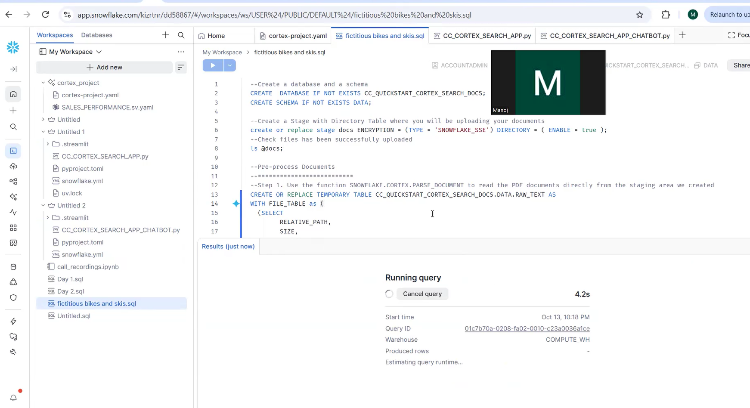

- CC_CORTEX_SEARCH_APP.py

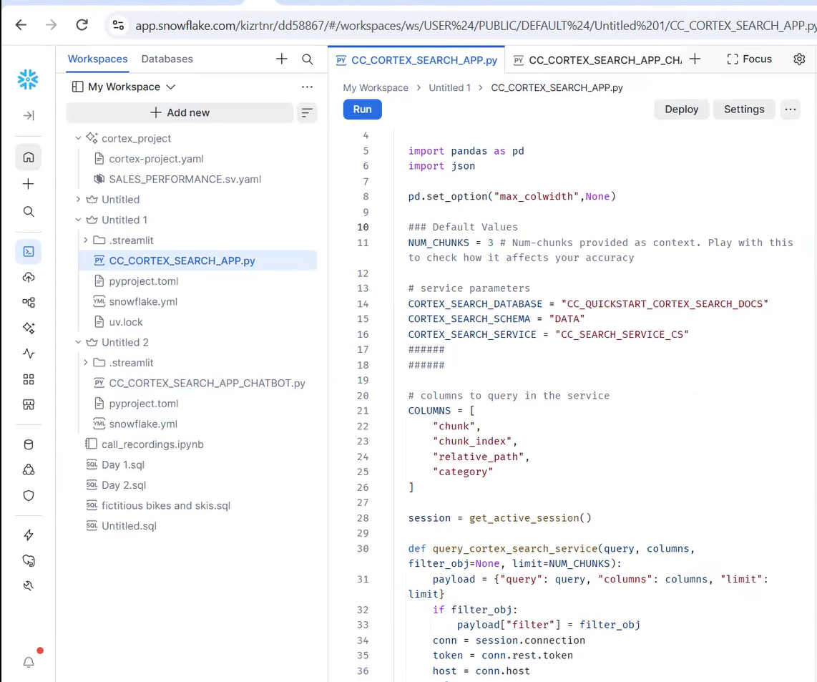

3.CC_CORTEX_SEARCH_APP_CHATBOT.py
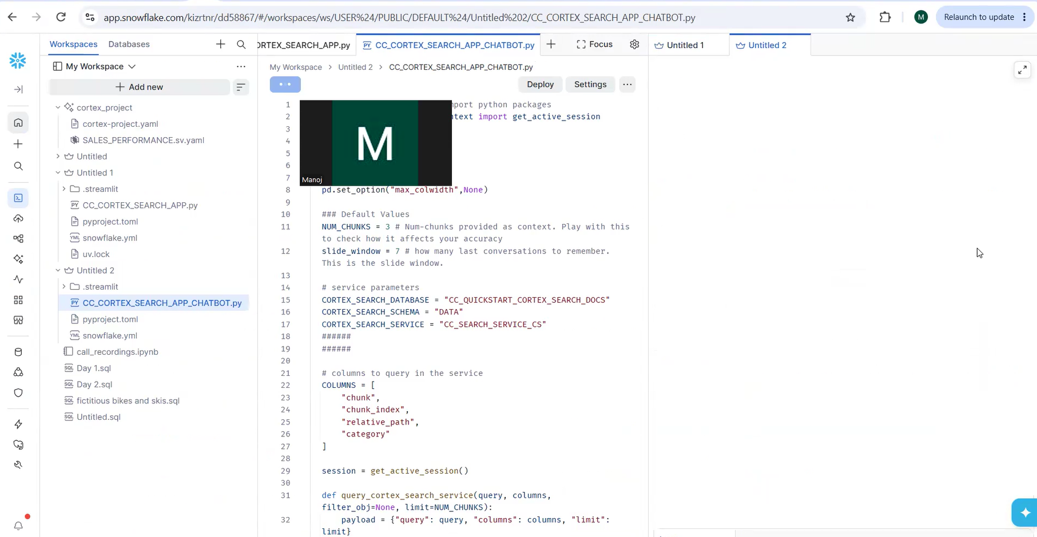
- Cortex Search App
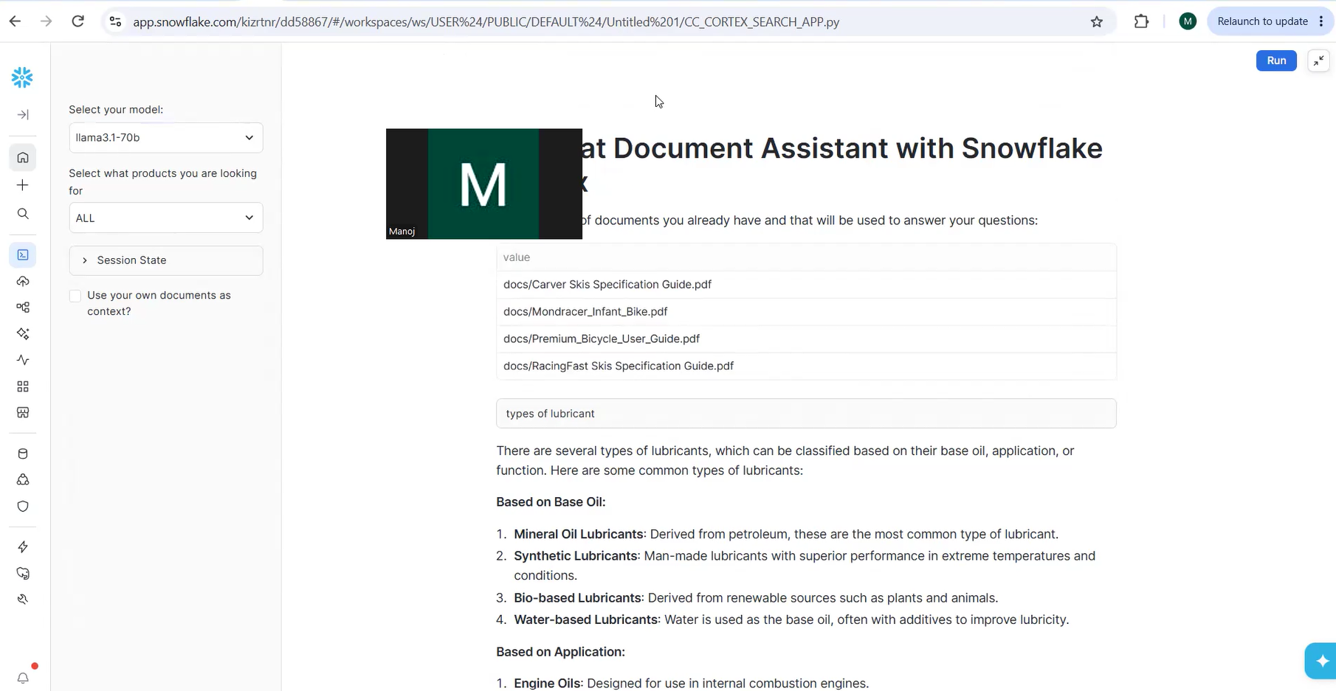
- Cortex Search App Chatbot

